UNIFIED FIELD OPERATIONS
Modern Inspection Programs Need One Controlled Path from Risk to Action
Three Shores AI Specializes In Inspection And Investigation Workflows Connecting Risk-Based Planning, Assignment Readiness, Guided Field Execution, Evidence Capture, Regulatory Reporting, and Compliance Follow-Up.
THE THREE SHORES AI DIFFERENCE A governed digital thread that keeps regulatory authority, inspection protocols, field evidence, and documented action connected.
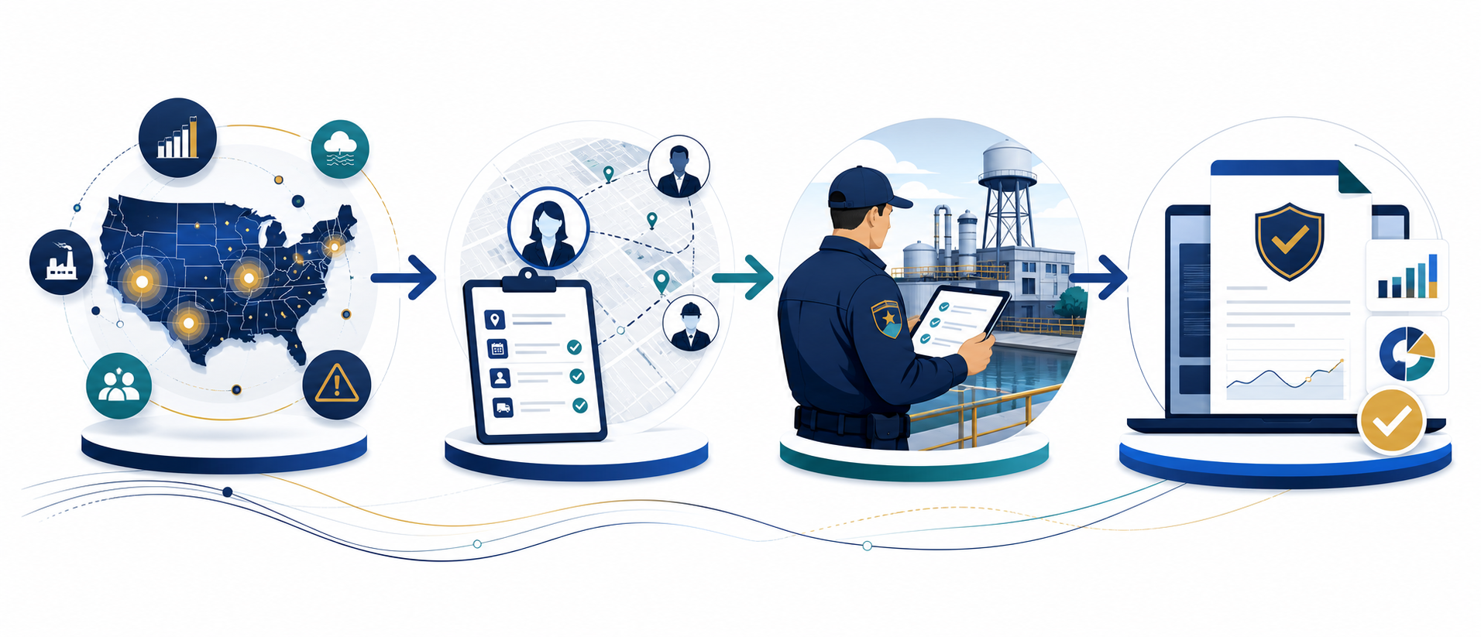
Risk-Based Intake • Consistent Planning • Ready Inspection Teams • Documented Follow-Up
01 Triage  Turn risk signals and triggers into a defined, reviewable intake path. | 02 Plan & Assign  Prepare validated assignments before inspectors enter the field. | 03 Execute  Guide inspections with protocols, context, notes, attachments, and evidence. | 04 Report  Connect findings, citations, EIR/483 drafting, and compliance follow-up.
Contact details available upon request. Capability descriptions are synthesized from Three Shores AI's Unified Field Operations product demonstration, 2026, and remain subject to discovery.

INSPECTION-READY AI
Bring Assistance into the Inspection Workflow—Not Alongside It
FIELD-MATE™ is Three Shores AI’s secure field capability for protocol-guided inspections. It combines approved-source retrieval, multimodal assistance, citation traceability, and structured reporting while preserving authorized human judgment.

Specialized Inspection Capabilities  Protocol intelligence converts 115+ approved inspection protocols into guided questionnaires. AI-assisted prioritization supports transparent review of firm risk. Vision, speech, and language capabilities support notes, labels, photos, video, and attachments. Automated citation tracking links observations to applicable authority and guidance. | Designed For Trusted Operations  Connected, disconnected, and fully air-gapped deployment patterns support field conditions and security boundaries. Approved sources, provenance, audit history, role-based access, human review, and use-case evaluation provide the operating controls needed for responsible adoption.
HOW THREE SHORES AI ENGAGES
A - Discover  Map triggers, planning, assignments, fieldwork, reporting, and systems. | B - Configure  Ingest protocols, connect authoritative data, and establish controls. | C - Pilot  Validate usability, quality, offline operation, and workflow outcomes. | D - Scale  Expand by protocol, program, user group, and approved deployment site.
POINTS OF  CONTACT | Muntaha Wali| Muntaha.wali@blendzit.com  Three Shores AI point of contact | Chetan Paul  Chetan.Paul@blendzit.com  Three Shores AI point of contact

